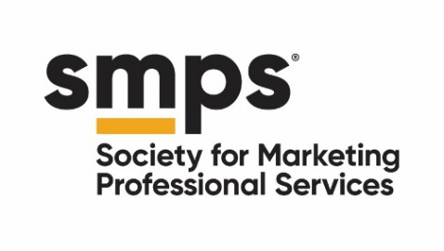

BOARD DIVERSITY MATRIX

Does your board have the skills and perspectives necessary to govern?

Increase the productivity of your board by ensuring you have the right mix of people. The right mix means:

- Your board should reflect the diversity of the population you serve, should be serving, or has a vested interest in your success. Age, race, gender identity, ability, experience, and geography are just a few of the factors that should be considered.

- Your board possesses the full range of skills and expertise necessary to facilitate governing in furtherance of your mission. For help determining what these should be, refer to your strategic plan, governing documents, and leadership.

Use the grid on the next page to analyze your board’s composition. The categories along the side can be changed to reflect the specific needs of your chapter. You may not have every category covered every board rotation, but over time you want to insure there is consistent representation of all interested parties. This can also highlight areas where the work of the board might be supplemented by committees. Leveraging the expertise of people outside of your board can be a valuable tool.

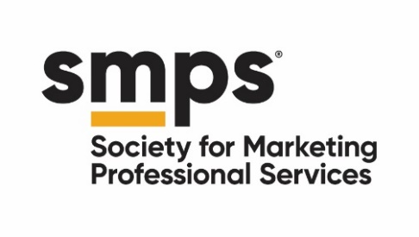

Board Member Name | Board Member
Gender
Female
Male
Non-binary
Prefer not to disclose
Age
21-35
36-50
51-65
Over 65
Prefer not to disclose
Race/Ethnicity
Asian
Black/African American
Hispanic/Latinx
Native American/Indigenous
White
Other
Prefer not to disclose
Expertise
Program
Planning/Evaluation
Legal
Personnel Administration
Graphic Design
Fundraising
Financial Management
Marketing
Business Development
Architecture
Engineering
Construction
Social Media
Networking
Affiliation
Union
Law Enforcement
Education
Political
Corporate
Media
Small Business
City/County/State

